|  |
| --- |
| Bayer Healthcare |
| Doc41 Web UI Administrator Guide |
| Usermanagement |
|  |
| **Christian Wegmann (Bayer Business Services GmbH)** |
| **10.02.2015** |

|  |
| --- |
|  |

|  |  |
| --- | --- |
| Infobox |  |
| Applicable System: | External Access: Doc41 Web UI |
| Title: | Administrator Guide |
| Author: | Ingo Kaulbach (EVFPU)  Christian Wegmann (EVAYD) |
| Change history (version number, last change, changed by, date) | 1. Ingo Kaulbach EVFPU, 2013-10-28, initial setup   1.1 Ingo Kaulbach EVFPU, 2014-01-15, infobox added  1.2 Ingo Kaulbach EVFPU, 2015-01-15, update  1.3 Ingo Kaulbach EVFPU, 2015-01-15, prettifying |
| Current Version of document: | 1.3 |
|  |  |

# Table of contents

Table of contents 2

User management 4

Overview 4

Create Bayer internal user 5

Create external user 6

Edit User 8

Internal 8

External 9

List of Figures 11

# User management

## Overview

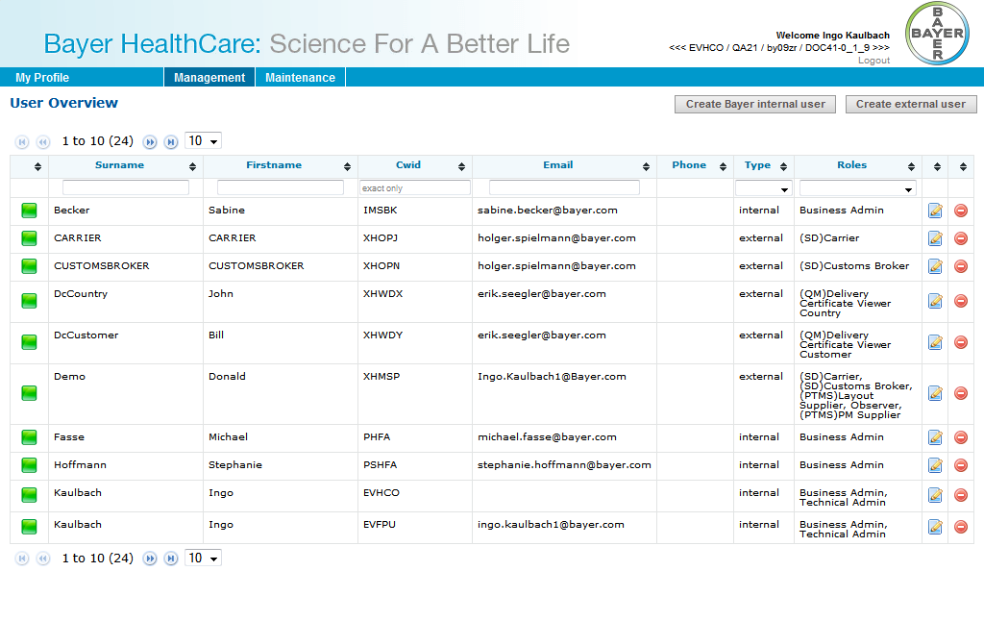

Image 1: User overview

This screen shows an overview of all users.

The users can be filtered by entering values in the header filter fields.  
The users can be sorted by clicking on the in the header fields.

The first icon indicates the status of the user: green for active, red for inactive. This status can be toggled by clicking the red/green icon in the last column. The icon in the second to last column opens the edit dialog.

There are two buttons to create an internal or external user.

## Create Bayer internal user

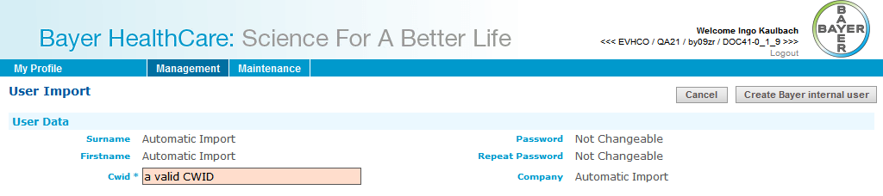

Image 2: User import

This screen is used for importing internal (=Bayer) users into the system. After a CWID is inserted and “Create Bayer internal user” is clicked, the Import Screen will be shown.

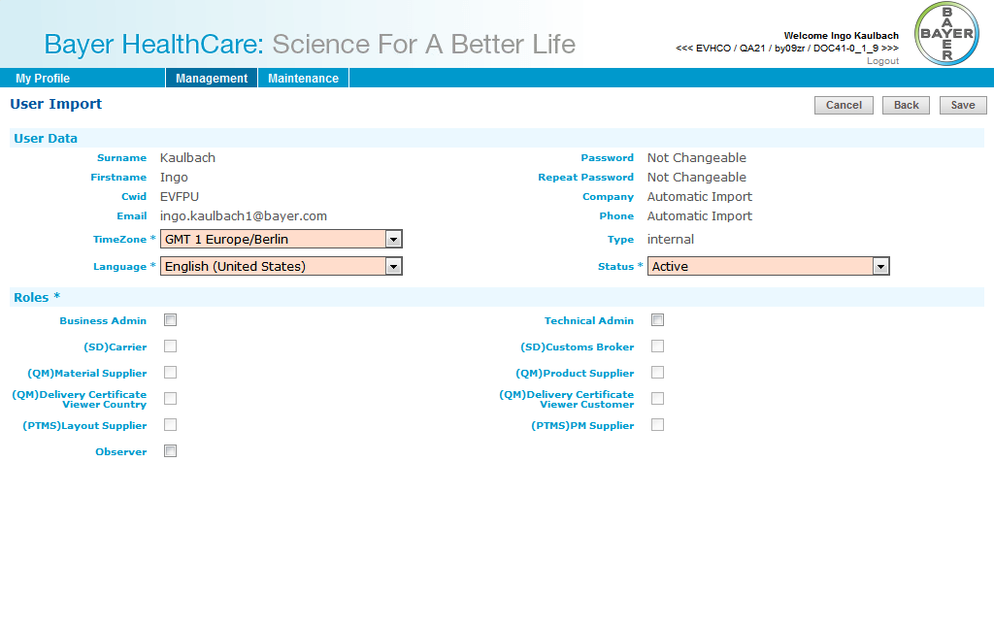

Image 3: Create internal user

Time zone, language and status of the user have to be set. Only active users can log into Doc41WebUI.

An internal user can have following roles:

* Business Admin
* Technical Admin
* *Observer*

Cancel will go back to user overview.  
Back will go back to enter another CWID.  
Save will create the user.

## Create external user

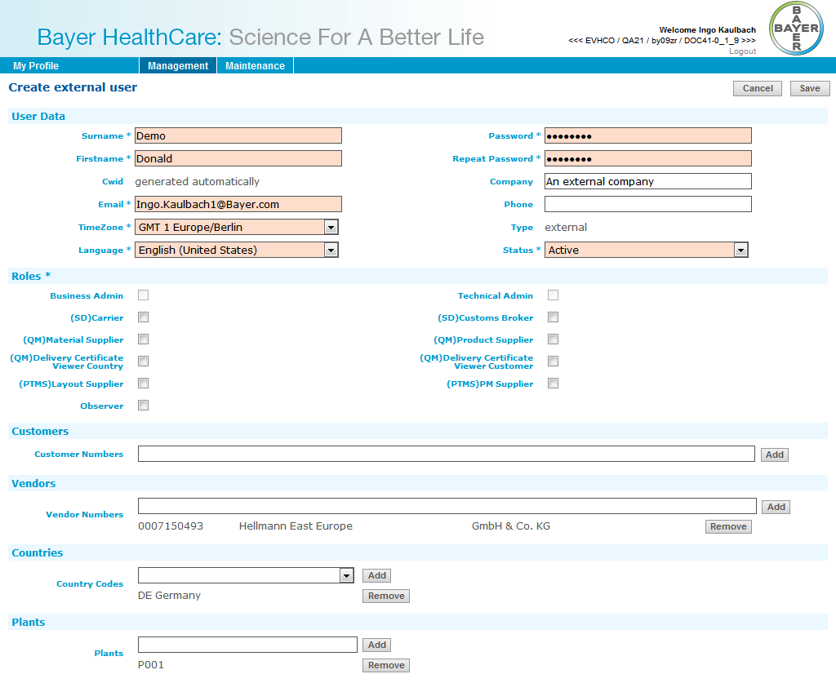

Image : Create external user

This screen is used for creating external users into the system.   
For external users First-, Surname, Email-Address and Password must be entered.

Time zone, language and status of the user have to be set. Only active users can log into Doc41WebUI.

An external user can have following roles:

* (SD) Carrier
* (SD) Customs Broker
* (QM) Material Supplier
* (QM) Product Supplier
* (QM) Delivery Certificate Viewer Country
* (QM) Delivery Certificate Viewer Customer
* (PTMS) Layout Supplier
* (PTMS) PM Supplier
* *Observer*

An external user can have Customers, Vendors, Countries and Plants.  
Customer and Vendor Numbers are only numbers (no letters etc.). After click on “Add”-button the partner will be searched in SAP and added to list, if found.  
Countries can be added from a list.  
Plants can be added as text. A Plant must only have numbers and upper case letters and a maximum length of 4.

Cancel will go back to user overview.  
Save will create the user.

## Edit User

This dialog is used for existing internal/external users. It looks like the User Import or Create external user dialog.

### Internal

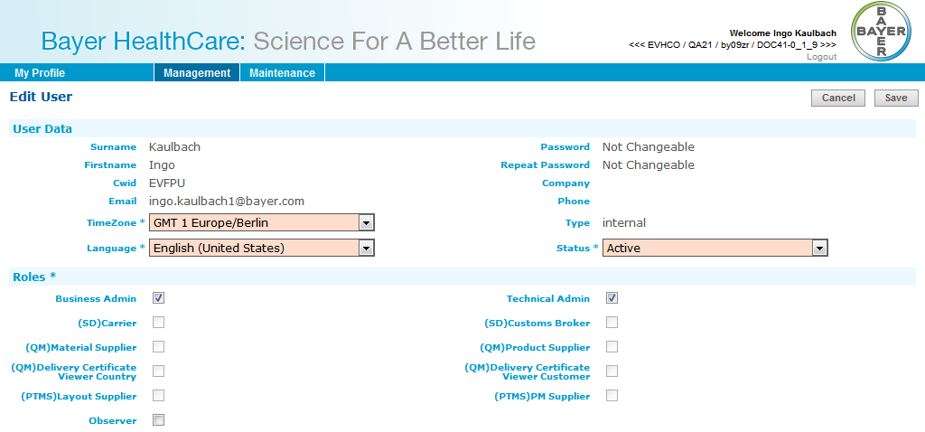

Image 5: Edit internal user

Time zone, language and status of the user can be changed.

Status of user can be changed, only active users can log into Doc41WebUI.

An internal user can have following roles:

* Business Admin
* Technical Admin
* *Observer*

Cancel will go back to user overview.

Save will update the user.

### External

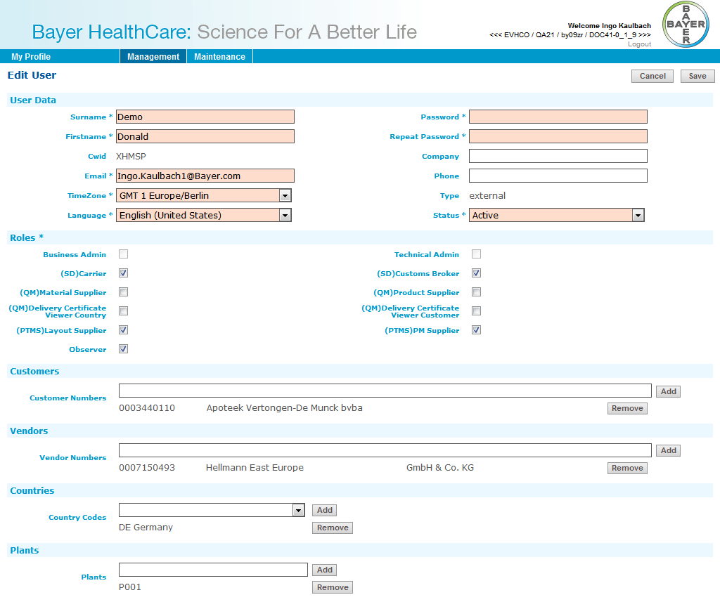

Image 6: Edit external user

For external users First-, Surname, Email-Address and Password can be changed as well as Time zone, language and Email-Address.

Status of user can be changed, only active users can log into Doc41WebUI.

An external user can have following roles:

* (SD) Carrier
* (SD) Customs Broker
* (QM) Material Supplier
* (QM) Product Supplier
* (QM) Delivery Certificate Viewer Country
* (QM) Delivery Certificate Viewer Customer
* (PTMS) Layout Supplier
* (PTMS) PM Supplier
* *Observer*

An external user can have Customers, Vendors, Countries and Plants.  
Customer and Vendor Numbers are only numbers (no letters etc.). After click on “Add”-button the partner will be searched in SAP and added to list, if found.  
Countries can be added from a list.  
Plants can be added as text. A Plant must only have numbers and upper case letters and a maximum length of 4.

Cancel will go back to user overview.  
Save will update the user.

# List of Figures

Image 1: User overview 4

Image 2: User import 5

Image 3: Create internal user 5

Image 4: Create external user 6

Image 5: Edit internal user 8

Image 6: Edit external user 9